March 12, 2021
Situational language learning
Baby care video:
https://www.youtube.com/watch?v=kXDwAuiyqY0

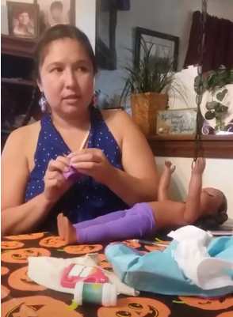

Discuss what you see in the video.
What language is used?
What is culturally appropriate?
hóhkėha'e hat
návóhkėha'e my hat

Natural language learning questions
Go to bed!
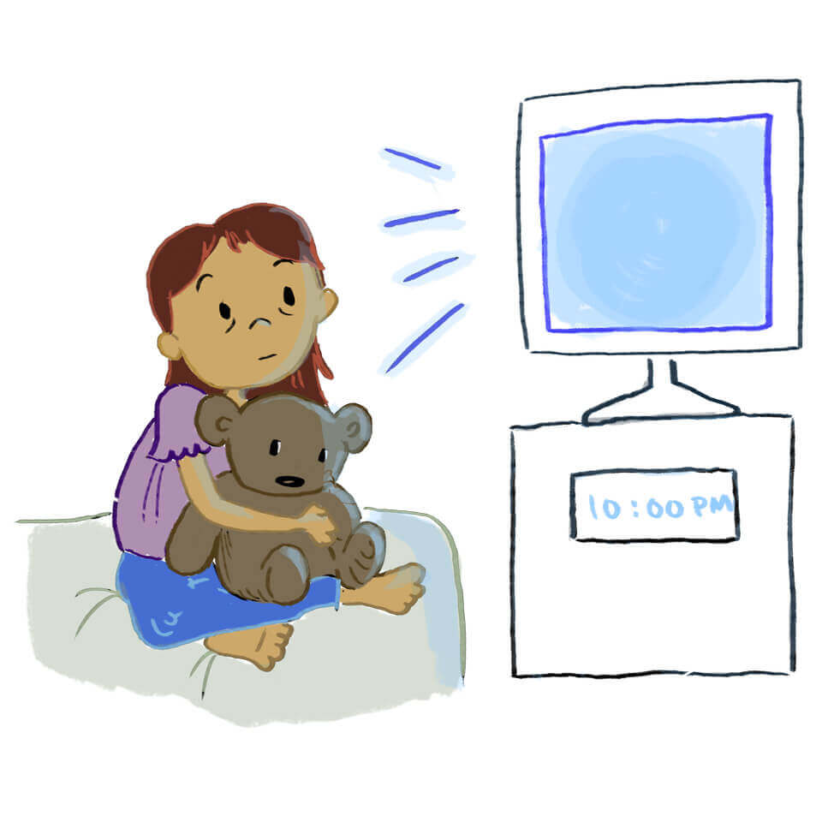
Don't ask in English, "How do you say 'Go to bed!"? (You might get the answer: "Tȧhetsėhe'ohtsėstse šéešestȯtse!" -- Cheyennes have words for "Go to" and "bed", but that's not what Cheyennes say in this situation.)
Instead, ask in Cheyenne, "Náme'óxȯhéto?" (What should I tell her?)

Go to bed!
We could literally translate each word:
šéešestȯtse bed (lying down thing)
Tȧhétsėhe'ohtsėstse! Go there! (phonetic tatsi'ohtsts)
Tȧhétsėhe'ohtsėstse šéešestȯtse (or probably šéešéstóva)! Literal, Go to bed!
But this is not what fluent Cheyenne speakers actually say.
Instead, they say Tȧhéovēšėstse! to one person and Tȧhéovēše! to more than one person.

Natural language learning questions
Take your shoes off!
Don't ask in English, "How do you say 'Take your shoes off!"? (You might get the answer: "Né'tánȯhtse nemo'kėhanȯtse! That would be understood but it is not what fluent Cheyennes say in this situation.)
Instead, ask in Cheyenne, "Náme'óxȯhéto?" (What should I tell her?) (You might also need to add something else in Cheyenne to be clearer, but I don't know how to say that something else.)
éohketsisióxȯhenove? How is it said it in Cheyenne?

Situational language learning
Talk only in Cheyenne at a meal
Discuss how this could be done only in Cheyenne if most of the family do not know much Cheyenne.
Vóhpoma'ȯhtse né'asėtānȯhtse! Pass the salt!
Monėškeho né'asėtanenano! Pass the beans!
Ho'évohkȯtse épéveéno'e. The meat tastes good.
Mahpe né'asėtanȯtse! Pass the water!
Épéveéno'e. It tastes good.
Násáaháeanáhe. I'm not hungry.
Náná'so'enohe. I'm full.

